

PROJECT NAME: COURSE REGISTRATION MANAGEMENT SYSTEM

# GROUP MEMBERS:

|  |  |  |
| --- | --- | --- |
| **NAME** | **ID** | **CONTRIBUTION** |
| .MD AKRAM HOSSAIN | 23-50745-1 | 20% |
| ARPITA ISLAM | 23-50712-1 | 20% |
| MD NAHIDUR RAHMAN | 23-50715-1 | 20% |
| MEHJABIN MOSTAFA | 23-50707-1 | 20% |
| . ESTIAK AHNED AL - NAHIAN | 23-50698-1 | 20% |

COURSE: INTRODUCTION TO DATABASE SECTION: j

# Table contents:

**Introduction ProjectScenario ER-Diagram Normalization SchemaDesign UserCreation TableCreation TableSequences TableInsertion QueryWriting RelationalAlgebra Conclusion**

# INTRODUCTION:

This project involves designing and implementing a Course Registration Management System for a university. Here are some key components and functionalities of the system

1.Student Enrollment • Students can enroll in various courses offered by the university each semester. • Enrollment records include student ID, name, program, and the courses they are enrolled in.

2.Course Details • Each course has specific details such as a course number, title, credits, , and prerequisites. • Courses may have multiple sections offered at different times .

3.Instructors • Instructors teach courses and are identified by their instructor ID and specific department. • Each section of a course is taught by a different instructor.

5.User Interfaces • The system should provide user-friendly interfaces for students to browse available courses, enroll in courses, and view their enrollment status and grades. • Instructors should have interfaces to manage their course sections, submit grades, and view student enrollment.

6.Administration and Management • Administrative users should have access to tools for managing course offerings, instructor assignments, and student records. • The system should support administrative tasks such as adding new courses, assigning instructors to courses, and generating reports on student enrollment and performance.

7.Security and Access Control • The system should implement security measures to protect student and instructor data. • Access control mechanisms should ensure that only authorized users can perform certain actions within the system.

Overall, the Course Registration Management System aims to streamline the process of course enrollment, facilitate effective teaching and learning, and provide administrators with tools for managing academic programs

and student records.

# Project Scenario:

In a University Course Registration Management System, students are enrolled each semester for various courses. Each course has specific details such as a title, credits, syllabus, and pre- requisites and course is identified by course number. Onecourses can be taken by many students. Additionally, courses are offered in different sections, each with its own instructor, course number (foreign key), timing, and classroomnumber. Sections are identified by section’s number. Students enroll in courses, and their enrollment records include their name, and program. Also, a student is identified by a student id. Instructors, identified by their instructor ID which is an unique property and specific departments who teach courses. Different sections are taken by different instructors. Farther, the enrollment of students in courses and grades awarded to students in each course are enrolled for must be appropriately modelled.

# ER-Diagram:

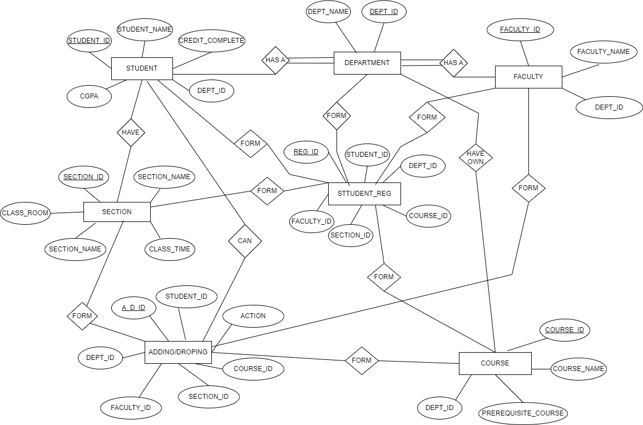

**Normalization: Have own**

UNF

Have own(dept_id,dept_name,course_id,course_name,prerequisite_course)

1. NF

There is no multivalued attribute .relation already in 1 NF

1. dept_id, dept_name,course_id, course_name,prerequisite_course

1. NF
2. dept_id, dept_name
3. course_id, course_name,prerequisite_course
4. NF

There is no transitive dependency , relation already in 3 NF

1. dept_id, dept_name

2 . course_id, course_name,prerequisite_course

Table creation

1 dept_id, dept_name

2 course_id, course_name,prerequisite_course,dept_id

# Has a

UNF

Has a(faculty_id,faculty_name,dept_id,dept_name)

1 NF

There is no multivalued attribute .relation already in 1 NF

1.faculty_id,faculty_name,dept_id,dept_name

2 NF

1. faculty_id,faculty_name

2. dept_id,dept_name

3 NF

There is no transitive dependency , relation already in 3 NF

1. faculty_id,faculty_name

2. dept_id,dept_name

Table creation

1 dept_id,dept_name

2 faculty_id,faculty_name,dept_id

**Has a**

UNF

Has a (dept_id, dept_name,student_id,student_name_cradit_complete,cgpa,)

1 NF

There is no multivalued attribute .relation already in 1 NF

1. dept_id, dept_name,student_id,student_name_cradit_complete,cgpa

2 NF

1. dept_id, dept_name

2. ,student_id,student_name_cradit_complete,cgpa

3 NF

There is no transitive dependency , relation already in 3 NF

1 .dept_id, dept_name

2 .,student_id,student_name_cradit_complete,cgpa

Table creation

1.dept_id, dept_name

2 .student_id,student_name_cradit_complete,cgpa,dept_id

**FORM**

UNF

FORM (student_id,student_name_cradit_complete,cgpa,dept_id,dept_id, dept_name, faculty_id,faculty_name,dept_id , course_id, course_name,prerequisite_course,dept_id,section_id,section_name,class_time,class_rom,a_d_id,student_id,action,course_id,section_idfaculty_id,dept_id)

1 NF

There is no multivalued attribute .relation already in 1 NF

1. student_id,student_name_cradit_complete,cgpa,dept_id,dept_id, dept_name, faculty_id,faculty_name,dept_id , course_id, course_name,prerequisite_course,dept_id,section_id,section_name,class_time,class_rom,a_d_id,student_id,action,course_id,section_idfaculty_id,dept_id)

2NF

1. dept_id, dept_name

2 . student_id,student_name_cradit_complete,cgpa,dept_id,faculty_id,faculty_name,dept_id , course_id,course_name,prerequisite_course,dept_id,section_id,section_name,class_time,class_rom,a_d_id,student_id,action,course_id,section_id,faculty_id,dept_id)

3 NF

1 section_id,section_name,class_time,class_rom

2.,student_id,action,course_id,section_id,faculty_id,dept_id

3.student_id,.dept_id,course_id,section_id,faculty_id,

Table creation

1. Section_id,section_name,class_time,class_rom

2. A_d_id,student_id,action,course_id,section_id,faculty_id,dept_id

3. Reg_id,student_id,.dept_id,course_id,section_id,faculty_id,

4.course_name,prerequisite_course,dept_id,section_id,section_name,class_time,class

**Can**

UNF

can(A_d_id,student_id,action,course_id,section_id,faculty_id,dept_id, student_id,student_name_cradit_complete,cgpa,dept_id

)

1 NF

There is no multivalued attribute .relation already in 1 NF

1. A_d_id,student_id,action,course_id,section_id,faculty_id,dept_id,dept_name,, student_id,student_name_cradit_complete,cgpa

2NF

1. A_d_id,student_id,action,course_id,section_id,faculty_id,dept_id,

2 . student_id,student_name,cradit_complete,cgpa,dept_id

3NF

1. student_id,student_name,cradit_complete,cgpa

2 . dept_id,dept_name

3. Course_id,section_id,faculty_id,dept_id

Table creation

1. dept_id, dept_name, student_id

2 . couse_id , course_name ,dept_id

3.student_id,student_name,cradit_complete,cgpa,dept_i

# Temporary Tables:

1. dept_id, dept_name, student_id

2 . couse_id , course_name ,dept_id

3.student_id,student_name,cradit_complete,cgpa,dept_id.

4. Section_id,section_name,class_time,class_rom

5. A_d_id,student_id,action,course_id,section_id,faculty_id,dept_id

6. Reg_id,student_id,.dept_id,course_id,section_id,faculty_id,

7. course_name,prerequisite_course,dept_id,section_id,section_name,class_time,class

8 dept_id,dept_name

9 dept_id, dept_name

# Final table:

1. dept_id, dept_name

2. course_id, course_name,prerequisite_course,dept_id

3. faculty_id,faculty_name,dept_id

4. student_id,student_name_cradit_complete,cgpa,dept_id

5.. Section_id,section_name,class_time,class_rom

6.. A_d_id,student_id,action,course_id,section_id,faculty_id,dept_id

7. Reg_id,student_id,.dept_id,course_id,section_id,faculty_id,

# Schema Design:

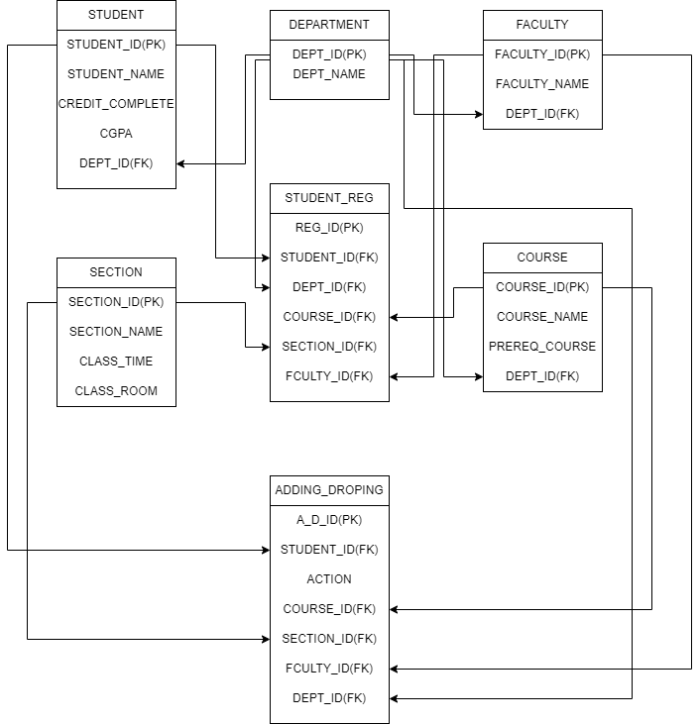

**User Creation:**

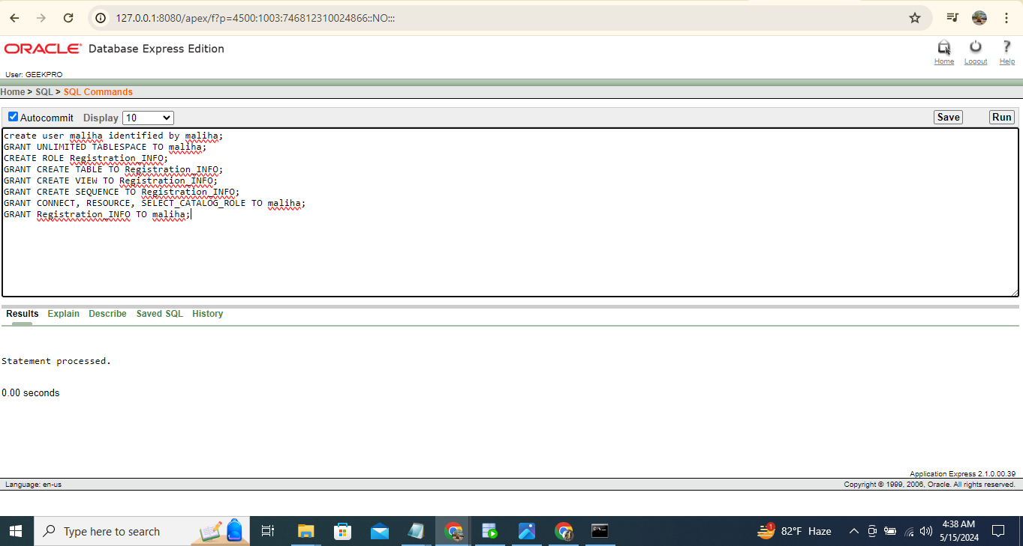

User create

create user maliha identified by maliha;

GRANT UNLIMITED TABLESPACE TO maliha;

CREATE ROLE Registration_INFO;

GRANT CREATE TABLE TO Registration_INFO;

GRANT CREATE VIEW TO Registration_INFO;

GRANT CREATE SEQUENCE TO Registration_INFO;

GRANT CONNECT, RESOURCE, SELECT_CATALOG_ROLE TO maliha;

GRANT Registration_INFO TO maliha;

**Table Creation (Screenshot):**

**1.department**

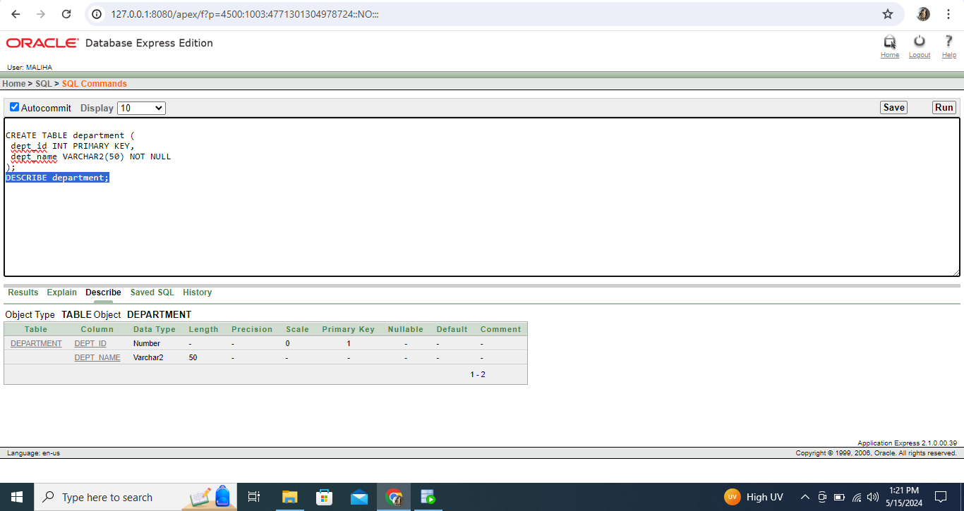

**2.course**

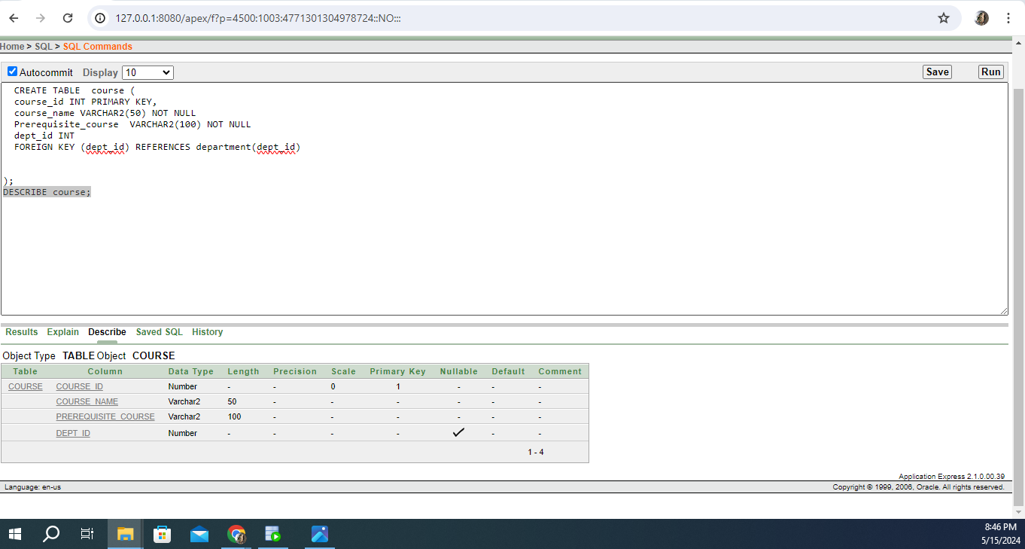

## 3.faculty

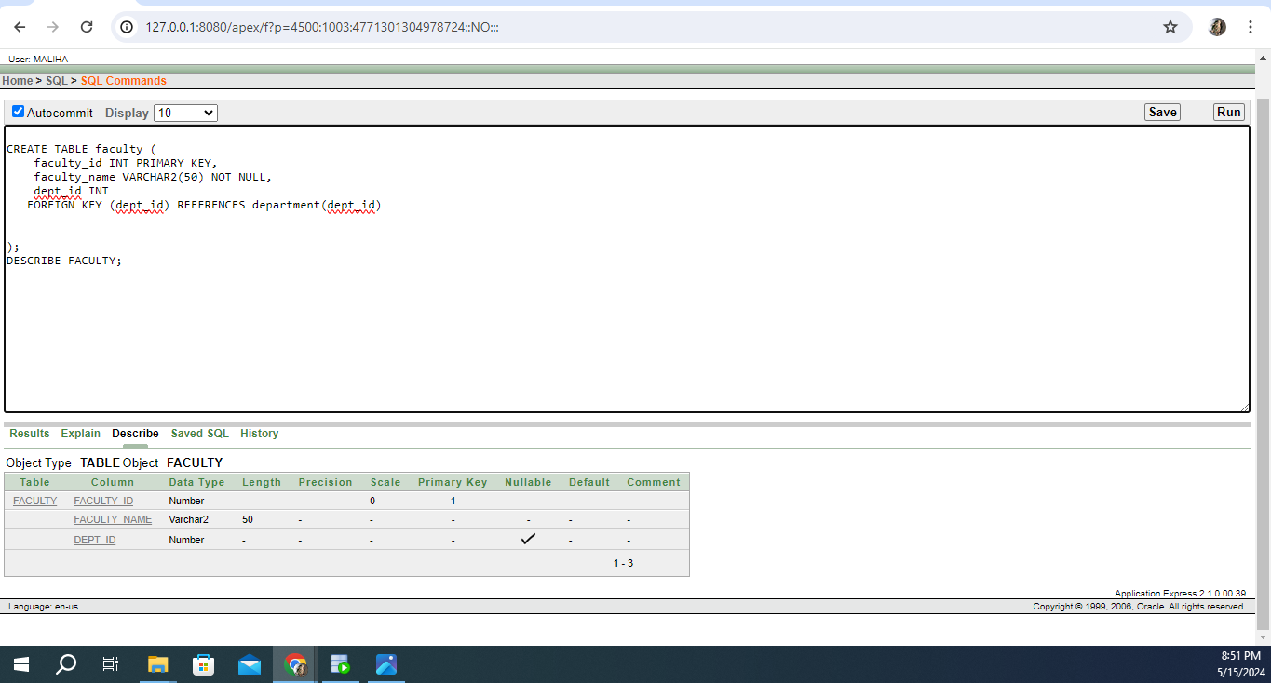

**4.section**

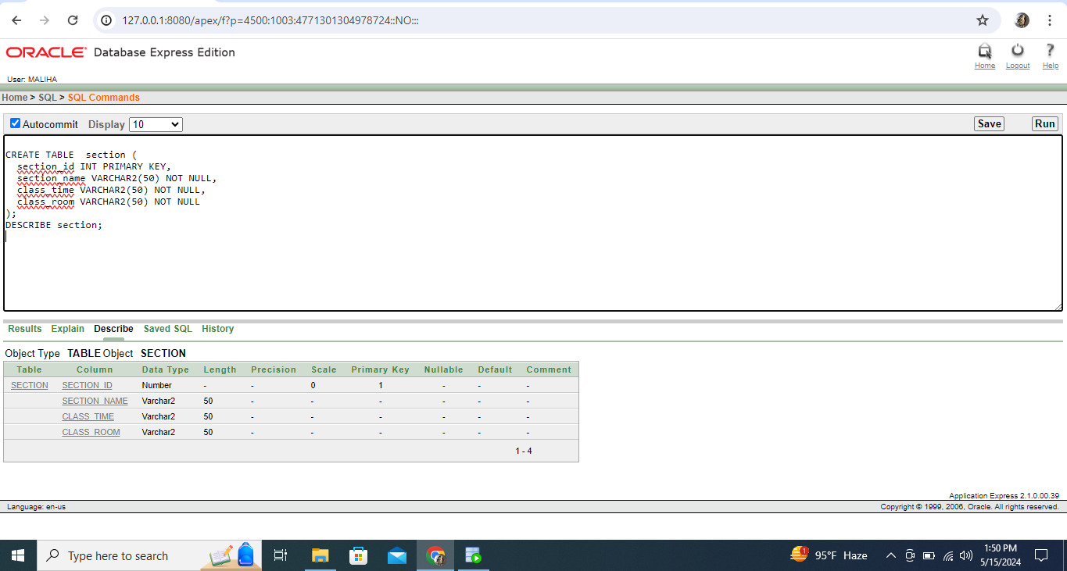

## 5.student

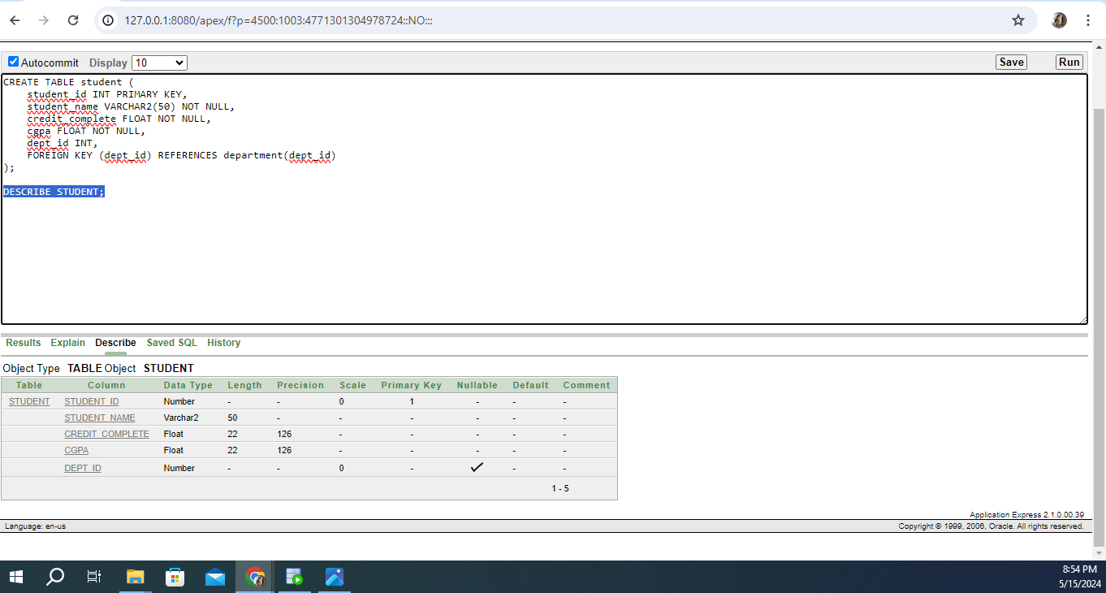

**6.studentreg**

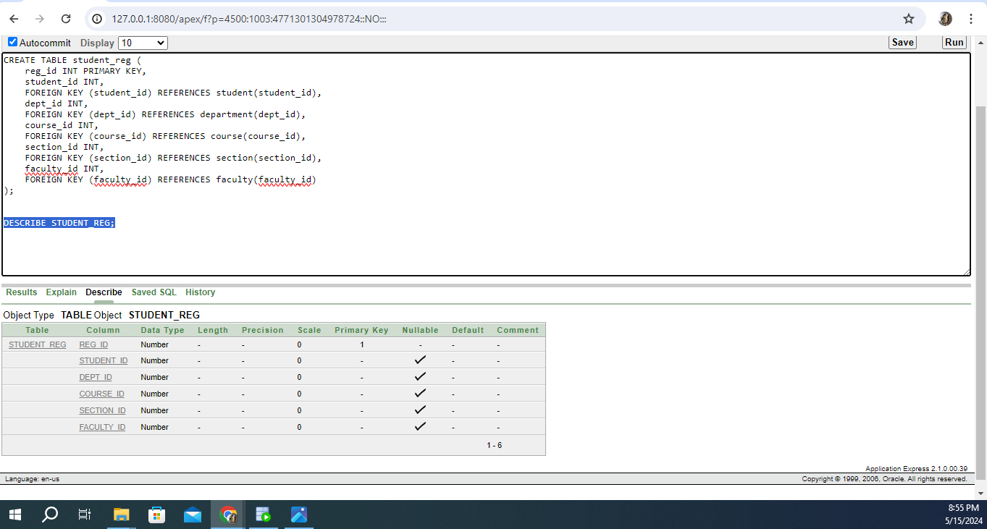

**7.adding/droping**

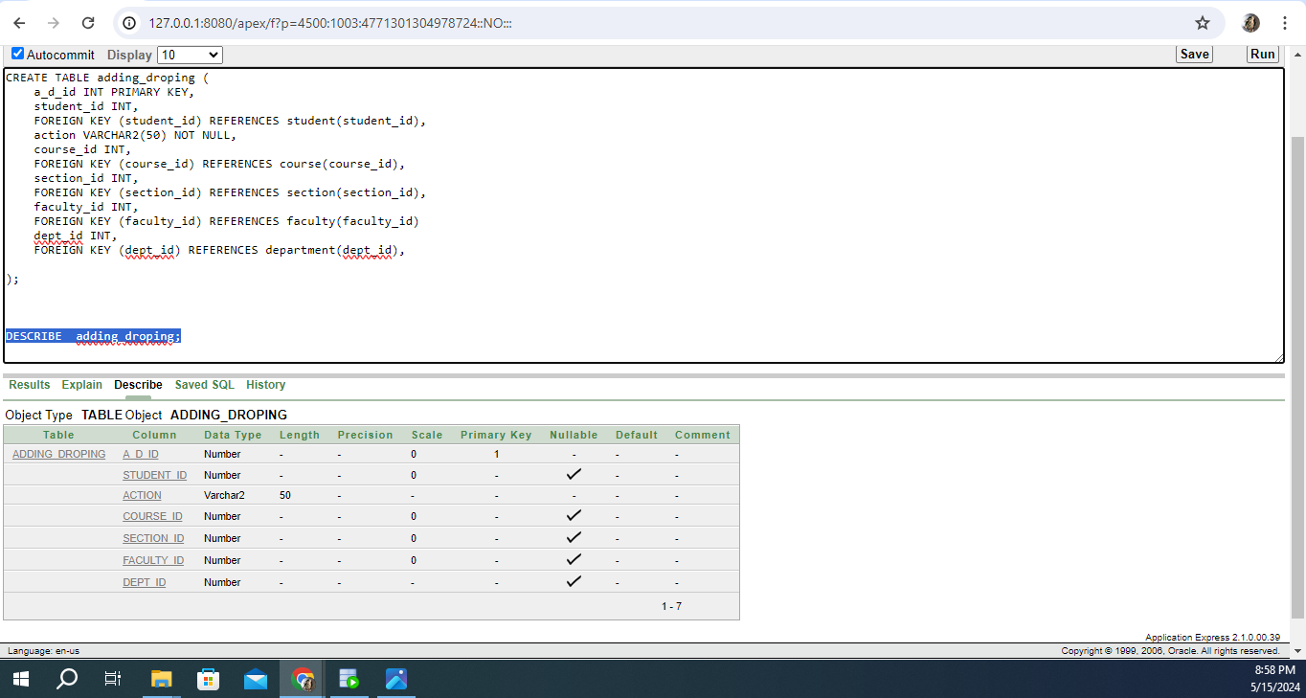

## Table Creation (Query):

TABLE

CREATE TABLE department (

dept_id INT PRIMARY KEY,

dept_name VARCHAR2(50) NOT NULL

);

DESCRIBE student;

CREATE TABLE faculty (

faculty_id INT PRIMARY KEY,

faculty_name VARCHAR2(50) NOT NULL,

dept_id INT

FOREIGN KEY (dept_id) REFERENCES department(dept_id)

);

CREATE TABLE course (

course_id INT PRIMARY KEY,

course_name VARCHAR2(50) NOT NULL

Prerequisite_course VARCHAR2(100) NOT NULL

dept_id INT

FOREIGN KEY (dept_id) REFERENCES department(dept_id)

);

DESCRIBE course;

CREATE TABLE section (

section_id INT PRIMARY KEY,

section_name VARCHAR2(50) NOT NULL,

class_time VARCHAR2(50) NOT NULL,

class_room VARCHAR2(50) NOT NULL

);

DESCRIBE section;

CREATE TABLE student (

student_id INT PRIMARY KEY,

student_name VARCHAR2(50) NOT NULL,

credit_complete FLOAT NOT NULL,

cgpa FLOAT NOT NULL,

dept_id INT,

FOREIGN KEY (dept_id) REFERENCES department(dept_id)

);

DESCRIBE STUDENT;

CREATE TABLE student_reg (

reg_id INT PRIMARY KEY,

student_id INT,

FOREIGN KEY (student_id) REFERENCES student(student_id),

dept_id INT,

FOREIGN KEY (dept_id) REFERENCES department(dept_id),

course_id INT,

FOREIGN KEY (course_id) REFERENCES course(course_id),

section_id INT,

FOREIGN KEY (section_id) REFERENCES section(section_id),

faculty_id INT,

FOREIGN KEY (faculty_id) REFERENCES faculty(faculty_id)

);

CREATE TABLE adding_droping (

a_d_id INT PRIMARY KEY,

student_id INT,

FOREIGN KEY (student_id) REFERENCES student(student_id),

action VARCHAR2(50) NOT NULL,

course_id INT,

FOREIGN KEY (course_id) REFERENCES course(course_id),

section_id INT,

FOREIGN KEY (section_id) REFERENCES section(section_id),

faculty_id INT,

FOREIGN KEY (faculty_id) REFERENCES faculty(faculty_id)

dept_id INT,

FOREIGN KEY (dept_id) REFERENCES department(dept_id),

);

DESCRIBE adding_droping;

## Table Sequences:

CREATE SEQUENCE dept_id

INCREMENT BY 1

START WITH 1

MAXVALUE 1000

NOCACHE

NOCYCLE;

CREATE SEQUENCE course_id

INCREMENT BY 1

START WITH 1

MAXVALUE 1000

NOCACHE

NOCYCLE;

CREATE SEQUENCE section_id

INCREMENT BY 1

START WITH 1

MAXVALUE 1000

NOCACHE

NOCYCLE;

CREATE SEQUENCE student_id

INCREMENT BY 1

START WITH 1

MAXVALUE 1000

NOCACHE

NOCYCLE;

CREATE SEQUENCE faculty_id

INCREMENT BY 1

START WITH 1

MAXVALUE 1000

NOCACHE

NOCYCLE;

CREATE SEQUENCE reg_id

INCREMENT BY 1

START WITH 1

MAXVALUE 1000

NOCACHE

NOCYCLE;

CREATE SEQUENCE a_d_id

INCREMENT BY 1

START WITH 1

MAXVALUE 1000

NOCACHE

NOCYCLE;

# Table Insertion (Screenshot):

**1.department**

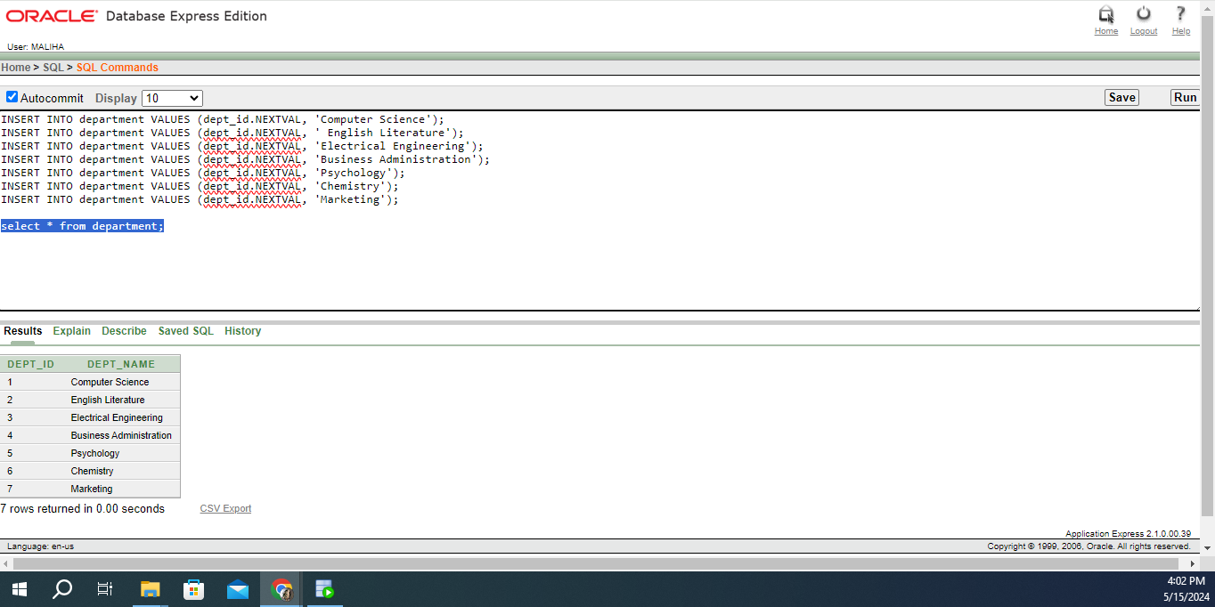

# 2.course

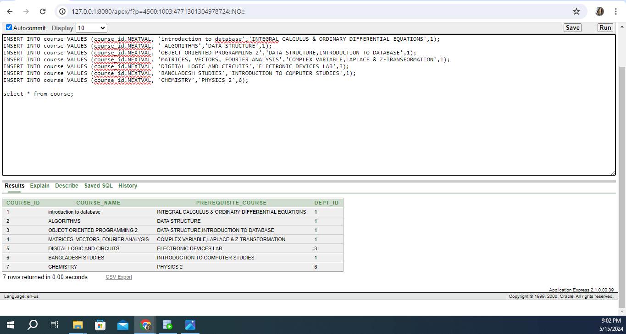

**3.faculty**

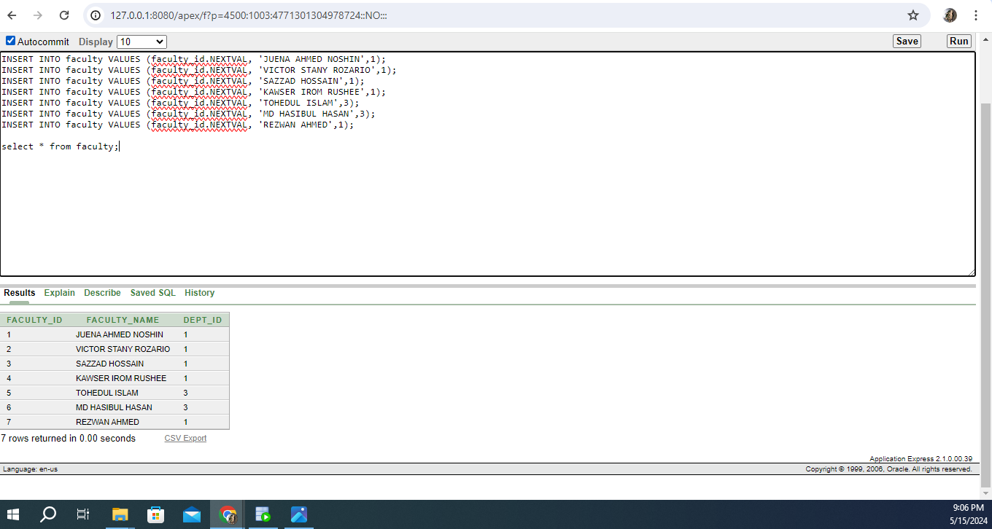

# 4.section

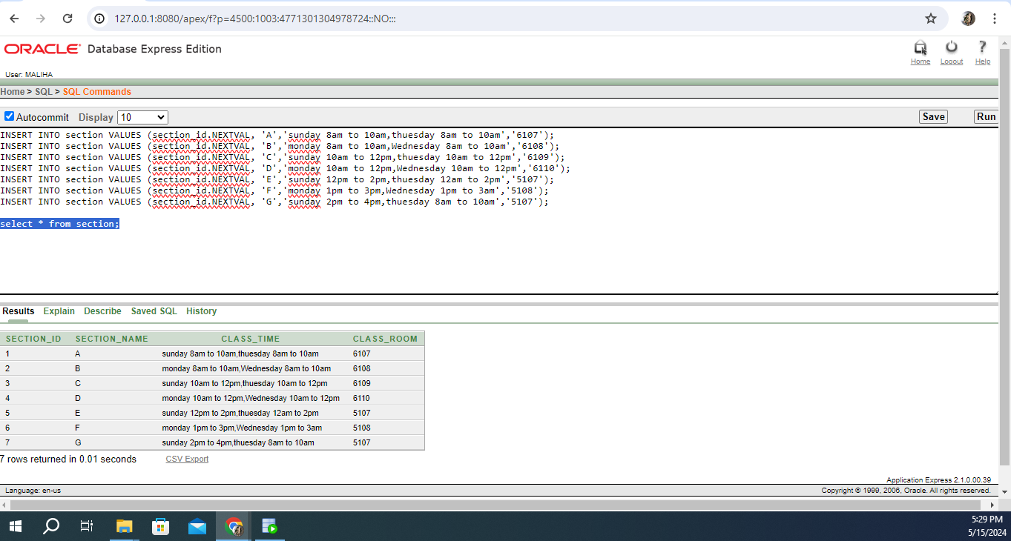

**5.student**

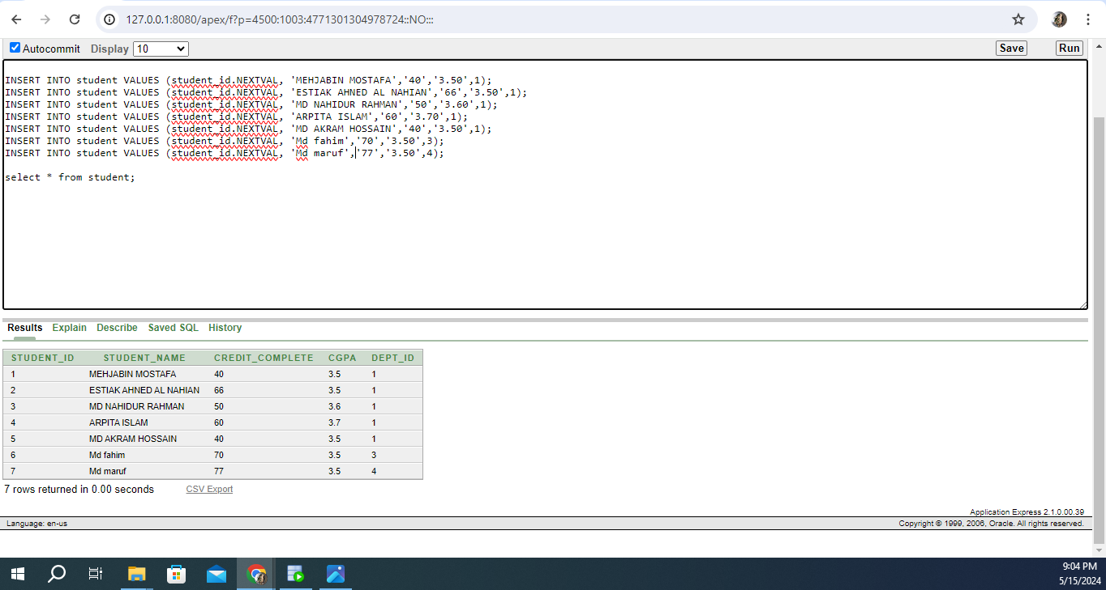

# 6.student_reg

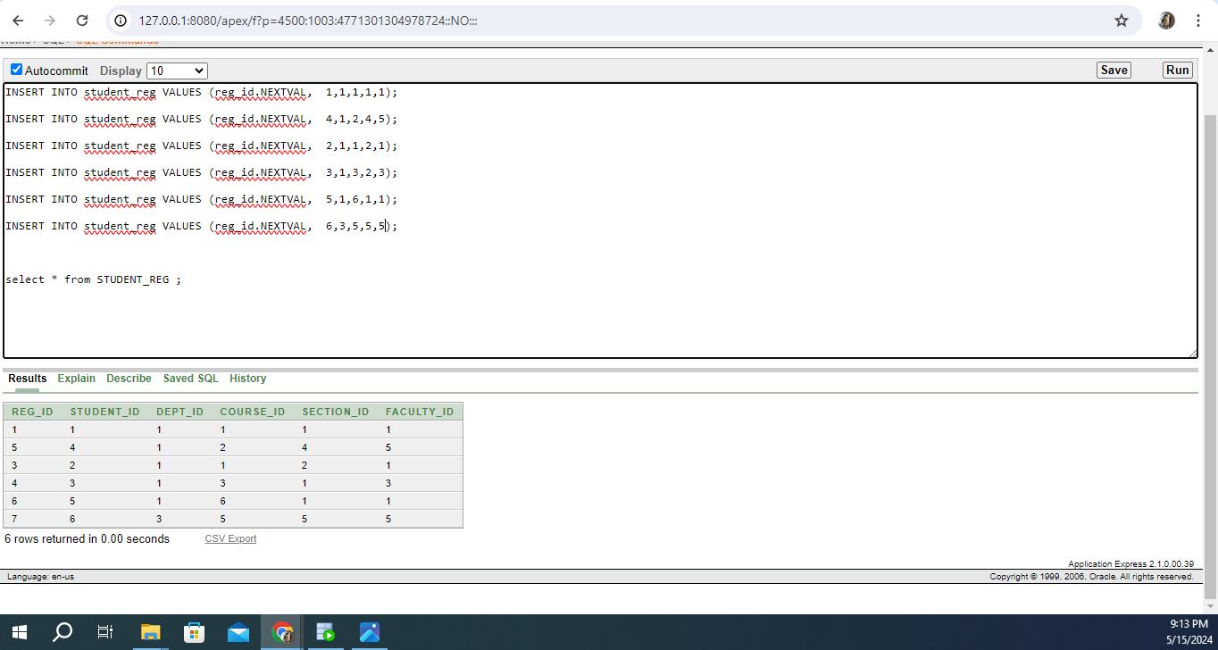

# 8.adding/dropding

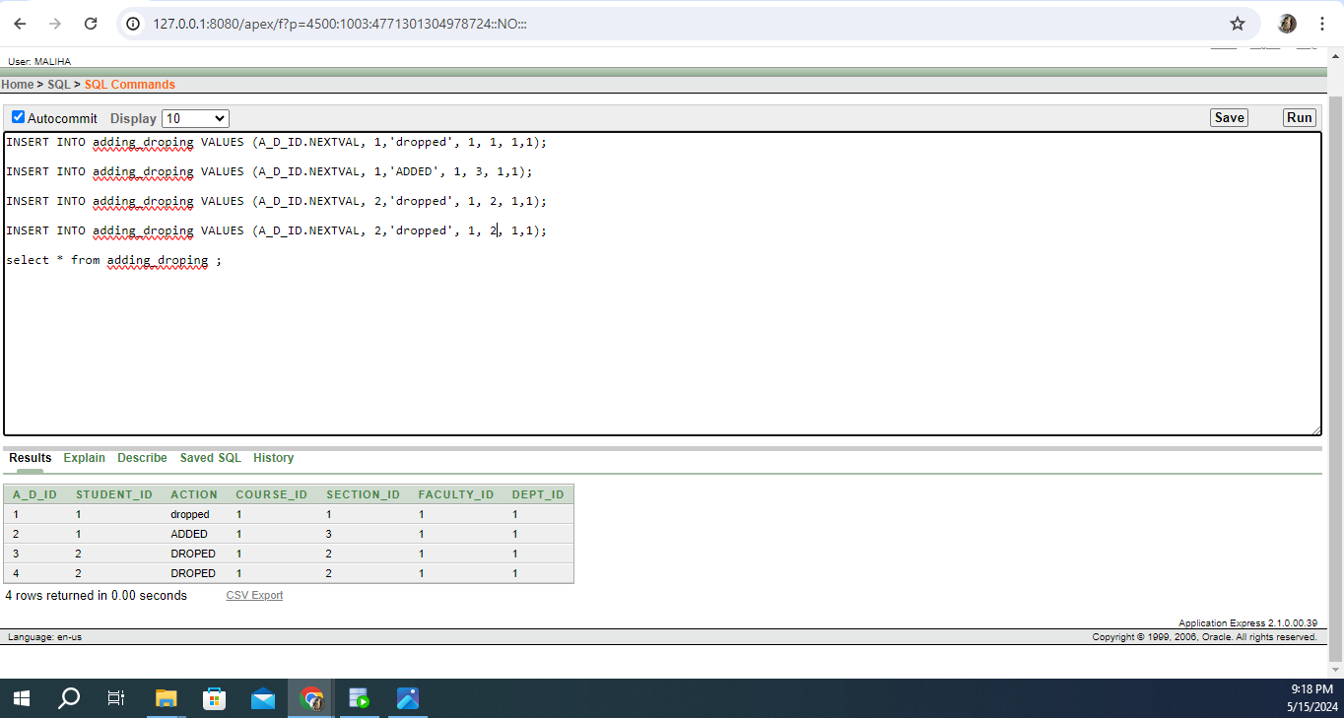

**Table Insertion:**

1.depertment

INSERT INTO department VALUES (dept_id.NEXTVAL, 'Computer Science');

INSERT INTO department VALUES (dept_id.NEXTVAL, ' English Literature');

INSERT INTO department VALUES (dept_id.NEXTVAL, 'Electrical Engineering');

INSERT INTO department VALUES (dept_id.NEXTVAL, 'Business Administration');

INSERT INTO department VALUES (dept_id.NEXTVAL, 'Psychology');

INSERT INTO department VALUES (dept_id.NEXTVAL, 'Chemistry');

INSERT INTO department VALUES (dept_id.NEXTVAL, 'Marketing');

select * from department;

2.course

INSERT INTO course VALUES (course_id.NEXTVAL, 'introduction to database','INTEGRAL CALCULUS & ORDINARY DIFFERENTIAL EQUATIONS',1);

INSERT INTO course VALUES (course_id.NEXTVAL, ' ALGORITHMS','DATA STRUCTURE',1);

INSERT INTO course VALUES (course_id.NEXTVAL, 'OBJECT ORIENTED PROGRAMMING 2','DATA STRUCTURE,INTRODUCTION TO DATABASE',1);

INSERT INTO course VALUES (course_id.NEXTVAL, 'MATRICES, VECTORS, FOURIER ANALYSIS','COMPLEX VARIABLE,LAPLACE & Z-TRANSFORMATION',1);

INSERT INTO course VALUES (course_id.NEXTVAL, 'DIGITAL LOGIC AND CIRCUITS','ELECTRONIC DEVICES LAB',1);

INSERT INTO course VALUES (course_id.NEXTVAL, 'BANGLADESH STUDIES','INTRODUCTION TO COMPUTER STUDIES',1);

INSERT INTO course VALUES (course_id.NEXTVAL, 'CHEMISTRY','PHYSICS 2',1);

select * from course;

3.section

INSERT INTO section VALUES (section_id.NEXTVAL, 'A','sunday 8am to 10am,thuesday 8am to 10am','6107');

INSERT INTO section VALUES (section_id.NEXTVAL, 'B','monday 8am to 10am,Wednesday 8am to 10am','6108');

INSERT INTO section VALUES (section_id.NEXTVAL, 'C','sunday 10am to 12pm,thuesday 10am to 12pm','6109');

INSERT INTO section VALUES (section_id.NEXTVAL, 'D','monday 10am to 12pm,Wednesday 10am to 12pm','6110');

INSERT INTO section VALUES (section_id.NEXTVAL, 'E','sunday 12pm to 2pm,thuesday 12am to 2pm','5107');

INSERT INTO section VALUES (section_id.NEXTVAL, 'F','monday 1pm to 3pm,Wednesday 1pm to 3am','5108');

INSERT INTO section VALUES (section_id.NEXTVAL, 'G','sunday 2pm to 4pm,thuesday 8am to 10am','5107');

select * from section;

4.student

INSERT INTO student VALUES (student_id.NEXTVAL, 'MEHJABIN MOSTAFA','40','3.50',1);

INSERT INTO student VALUES (student_id.NEXTVAL, 'ESTIAK AHNED AL NAHIAN','66','3.50',1);

INSERT INTO student VALUES (student_id.NEXTVAL, 'MD NAHIDUR RAHMAN','50','3.60',1);

INSERT INTO student VALUES (student_id.NEXTVAL, 'ARPITA ISLAM','60','3.70',1);

INSERT INTO student VALUES (student_id.NEXTVAL, 'MD AKRAM HOSSAIN','40','3.50',1);

INSERT INTO student VALUES (student_id.NEXTVAL, 'Md fahim','70','3.50',3);

INSERT INTO student VALUES (student_id.NEXTVAL, 'Md maruf','77','3.50',4);

select * from student;

5.faculty

INSERT INTO faculty VALUES (faculty_id.NEXTVAL, 'JUENA AHMED NOSHIN',1);

INSERT INTO faculty VALUES (faculty_id.NEXTVAL, 'VICTOR STANY ROZARIO',1);

INSERT INTO faculty VALUES (faculty_id.NEXTVAL, 'SAZZAD HOSSAIN',1);

INSERT INTO faculty VALUES (faculty_id.NEXTVAL, 'KAWSER IROM RUSHEE',1);

INSERT INTO faculty VALUES (faculty_id.NEXTVAL, 'TOHEDUL ISLAM',3);

INSERT INTO faculty VALUES (faculty_id.NEXTVAL, 'MD HASIBUL HASAN',3);

INSERT INTO faculty VALUES (faculty_id.NEXTVAL, 'REZWAN AHMED',1);

select * from faculty;

6.studen_reg

INSERT INTO student_reg VALUES (reg_id.NEXTVAL, 1,1,1,1,1);

INSERT INTO student_reg VALUES (reg_id.NEXTVAL, 4,1,2,4,5);

INSERT INTO student_reg VALUES (reg_id.NEXTVAL, 2,1,1,2,1);

INSERT INTO student_reg VALUES (reg_id.NEXTVAL, 3,1,3,2,3);

INSERT INTO student_reg VALUES (reg_id.NEXTVAL, 5,1,6,1,1);

INSERT INTO student_reg VALUES (reg_id.NEXTVAL, 6,3,5,5,5);

select * from STUDENT_REG ;

7.adding/droping

INSERT INTO adding_droping VALUES (A_D_ID.NEXTVAL, 1,'dropped', 1, 1, 1,1);

INSERT INTO adding_droping VALUES (A_D_ID.NEXTVAL, 1,'ADDED', 1, 3, 1,1);

INSERT INTO adding_droping VALUES (A_D_ID.NEXTVAL, 2,'dropped', 1, 2, 1,1);

INSERT INTO adding_droping VALUES (A_D_ID.NEXTVAL, 2,'dropped', 1, 2, 1,1);

select * from adding_droping ;

# Query Writing:

SINGLE ROW FUNCTION

1. Retrieve the full name of the student with STUDENT_ID 3 from the STUDENT table.:

SELECT STUDENT_NAME FROM STUDENT WHERE STUDENT_ID = 3;

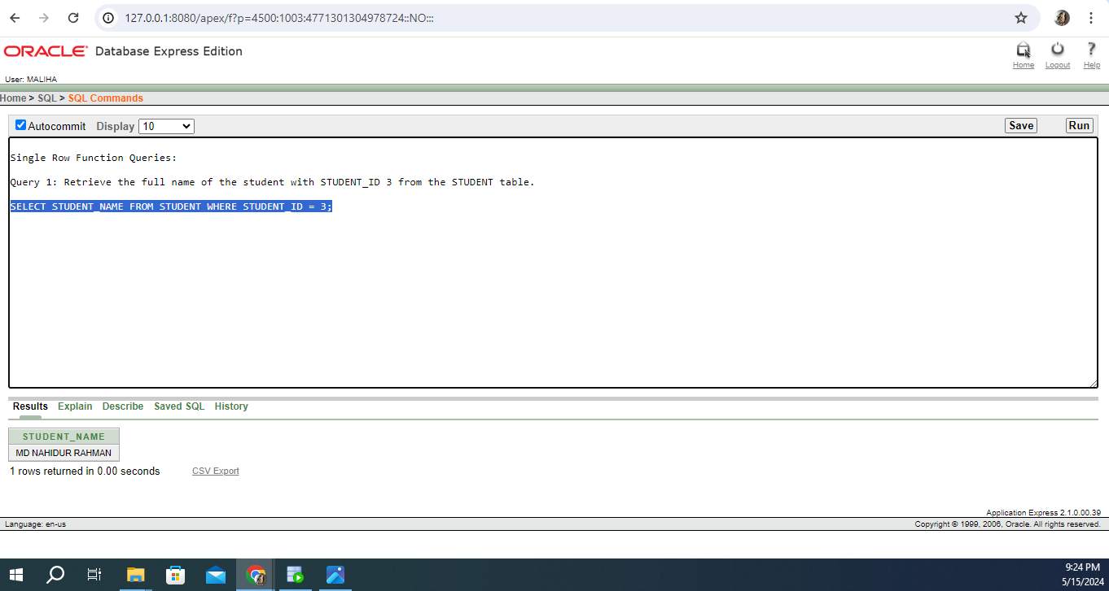

1. Calculate the total credits completed by the student with STUDENT_ID 4 from the STUDENT table.

SELECT SUM(CREDIT_COMPLETE) AS Total_Credits_Completed FROM STUDENT WHERE STUDENT_ID = 4;

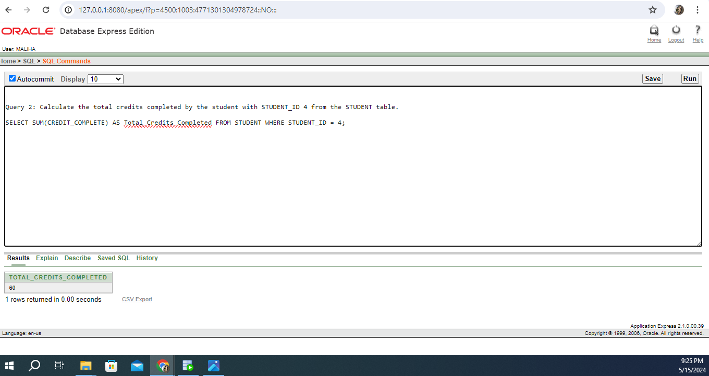

**2. GROUP FUNCTION**

1. Calculate the average CGPA of all students in the STUDENT table.

SELECT AVG(CGPA) AS Average_CGPA FROM STUDENT;

1.

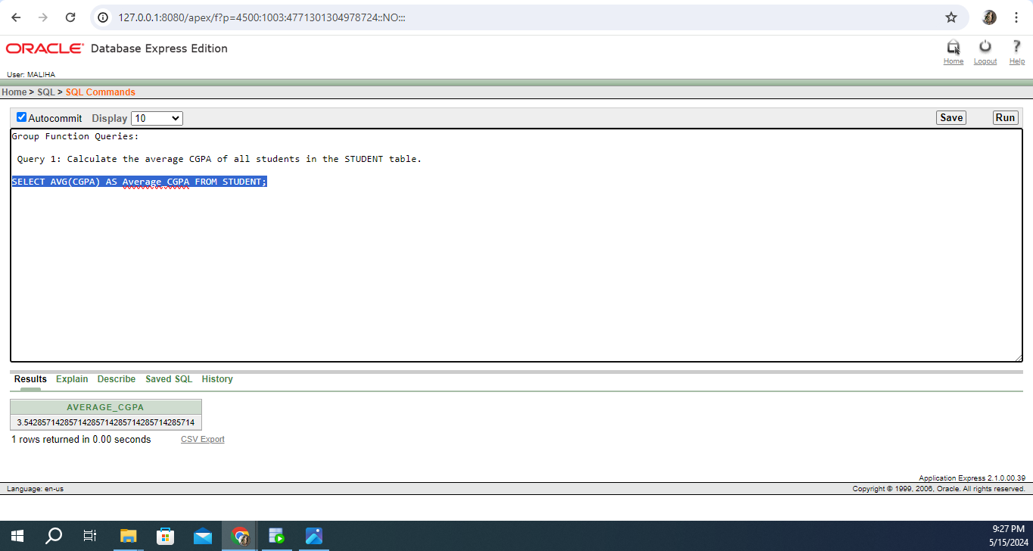

2.Count the number of students in each department.

SELECT DEPT_ID, COUNT(*) AS Student_Count FROM STUDENT GROUP BY DEPT_ID;

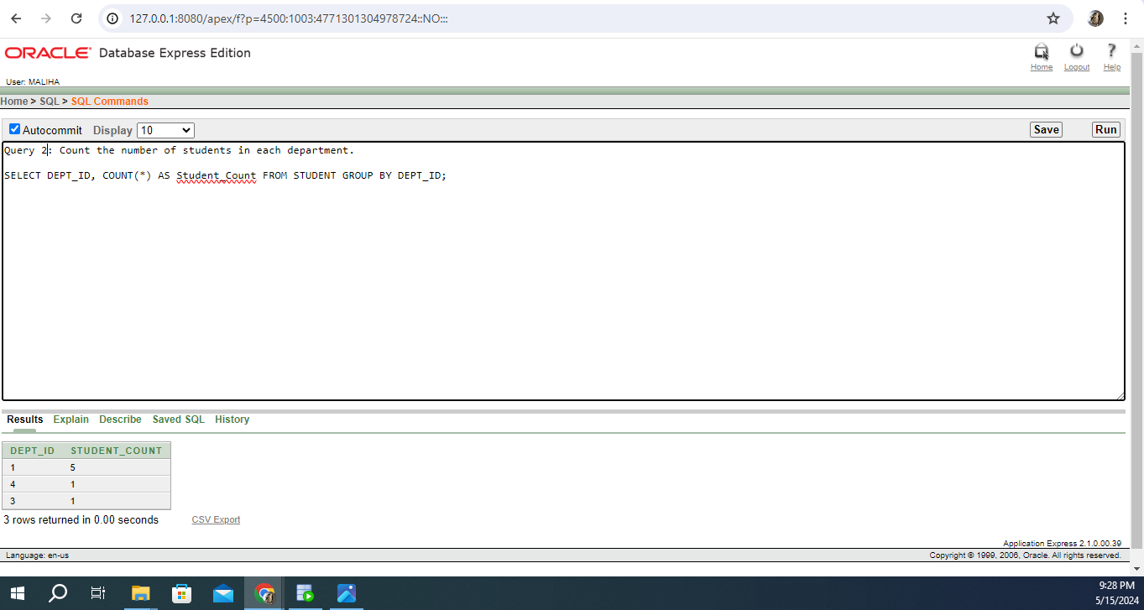

**subquery :**

1. Retrieve the names of students who have completed more credits than the average credits completed by all students.

SELECT STUDENT_NAME FROM STUDENT WHERE CREDIT_COMPLETE > (SELECT AVG(CREDIT_COMPLETE) FROM STUDENT);

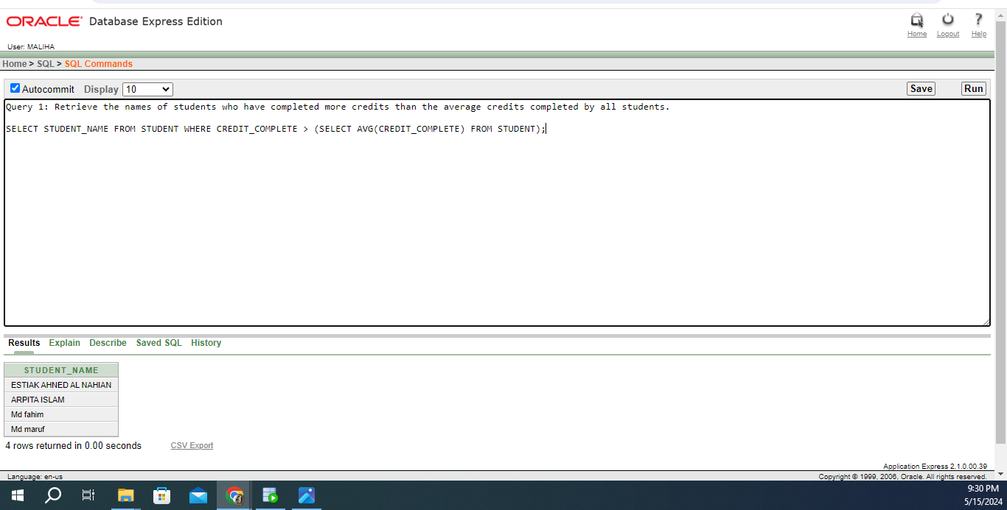

1. Retrieve the names of students who have a CGPA greater than the average CGPA of students in their department..

SELECT STUDENT_NAME

FROM STUDENT

WHERE CGPA > (SELECT AVG(CGPA) FROM STUDENT s2 WHERE s2.DEPT_ID = STUDENT.DEPT_ID);

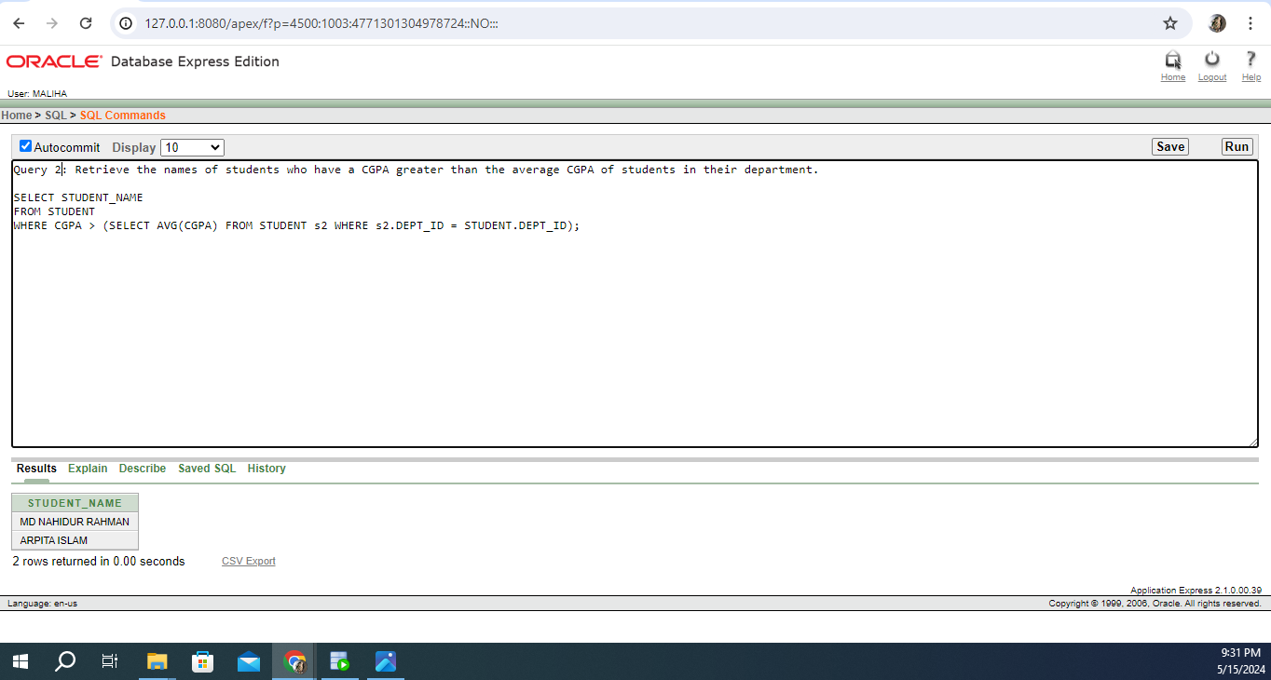

JOINING :

1.Retrieve the course name, section name, and class time for each course.

SELECT C.COURSE_NAME, S.SECTION_NAME, S.CLASS_TIME

FROM COURSE C

JOIN SECTION S ON C.COURSE_ID = S.SECTION_ID;

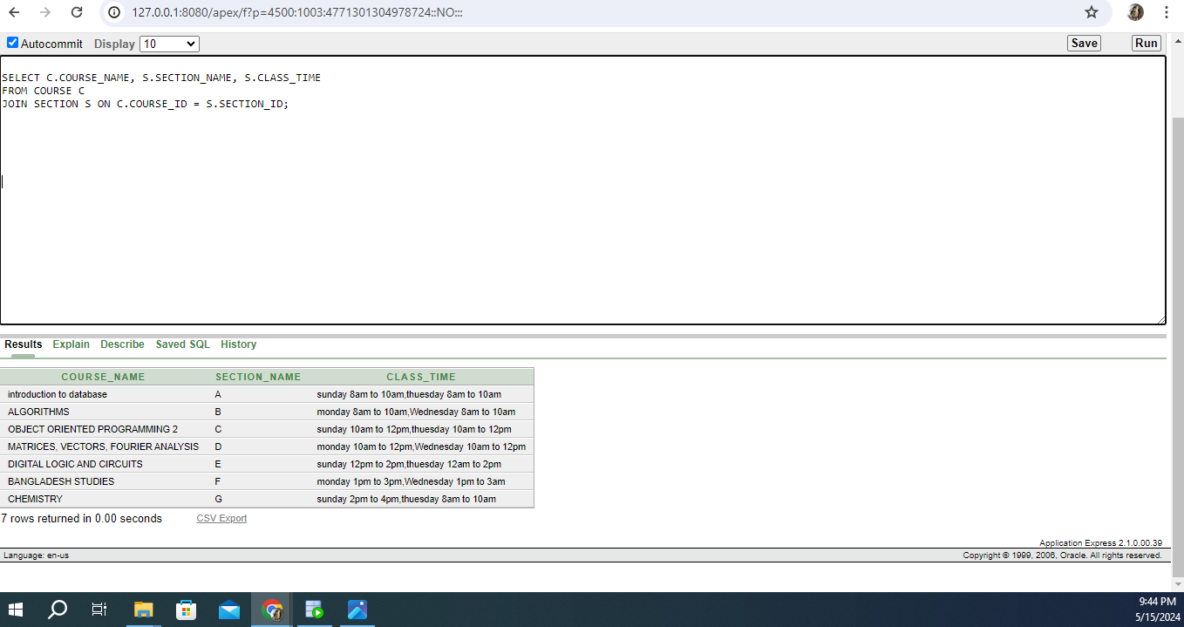

2.To retrieve student registration information along with course name, department name, faculty name, class time, and room number.

SELECT

SR.STUDENT_ID,

S.STUDENT_NAME,

C.COURSE_NAME,

D.DEPT_NAME,

F.FACULTY_NAME,

SEC.CLASS_TIME,

SEC.CLASS_ROOM

FROM

STUDENT_REG SR

JOIN

STUDENT S ON SR.STUDENT_ID = S.STUDENT_ID

JOIN

COURSE C ON SR.COURSE_ID = C.COURSE_ID

JOIN

DEPARTMENT D ON C.DEPT_ID = D.DEPT_ID

JOIN

FACULTY F ON SR.FACULTY_ID = F.FACULTY_ID

JOIN

SECTION SEC ON SR.SECTION_ID = SEC.SECTION_ID;

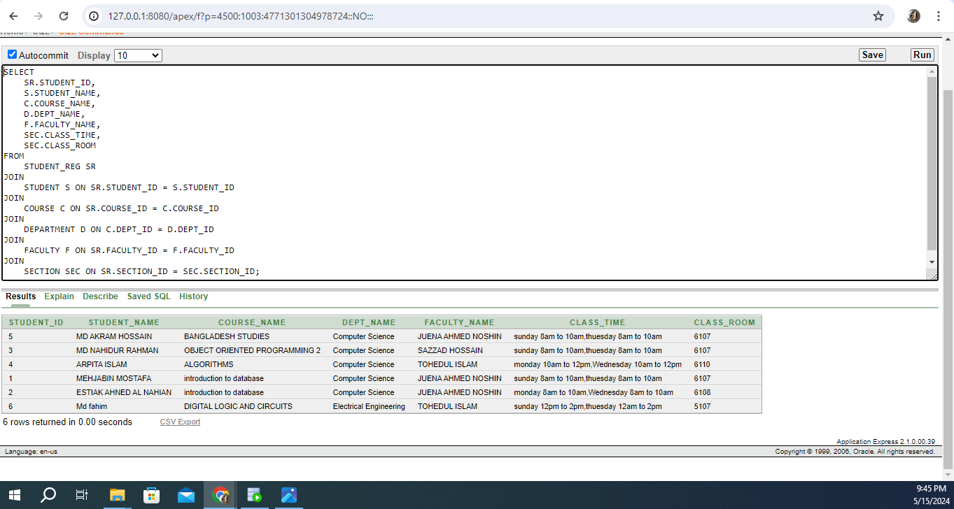

**view:**

1.This view will provide a summary of student enrollment, showing the number of students enrolled in each course.

CREATE VIEW Course_Enrollment AS

SELECT

C.COURSE_ID,

C.COURSE_NAME,

COUNT(SR.STUDENT_ID) AS Enrollment_Count

FROM

STUDENT_REG SR

JOIN

COURSE C ON SR.COURSE_ID = C.COURSE_ID

GROUP BY

C.COURSE_ID, C.COURSE_NAME;

SELECT * FROM Course_Enrollment

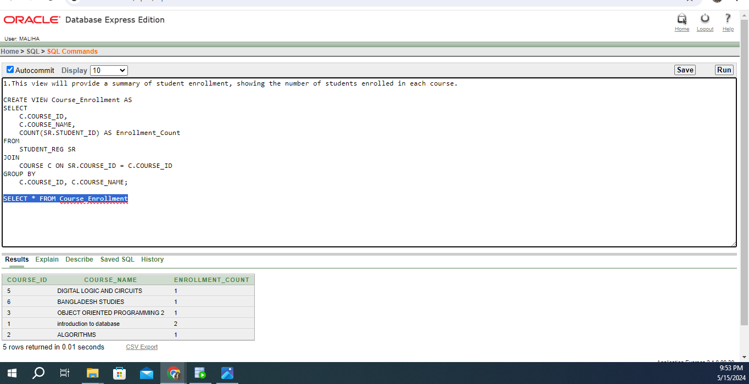

2.To create a view that includes information about students' course enrollment and any actions related to adding or dropping courses

CREATE VIEW Student_Enrollment_Info AS

SELECT

SR.STUDENT_ID,

S.STUDENT_NAME,

C.COURSE_NAME,

D.DEPT_NAME,

F.FACULTY_NAME,

SEC.CLASS_TIME,

SEC.CLASS_ROOM,

AD.ACTION

FROM

STUDENT_REG SR

JOIN

STUDENT S ON SR.STUDENT_ID = S.STUDENT_ID

JOIN

COURSE C ON SR.COURSE_ID = C.COURSE_ID

JOIN

DEPARTMENT D ON C.DEPT_ID = D.DEPT_ID

JOIN

FACULTY F ON SR.FACULTY_ID = F.FACULTY_ID

JOIN

SECTION SEC ON SR.SECTION_ID = SEC.SECTION_ID

LEFT JOIN

ADDING_DROPING AD ON SR.STUDENT_ID = AD.STUDENT_ID AND SR.COURSE_ID = AD.COURSE_ID AND SR.SECTION_ID = AD.SECTION_ID;

SELECT * FROM Student_Enrollment_Info

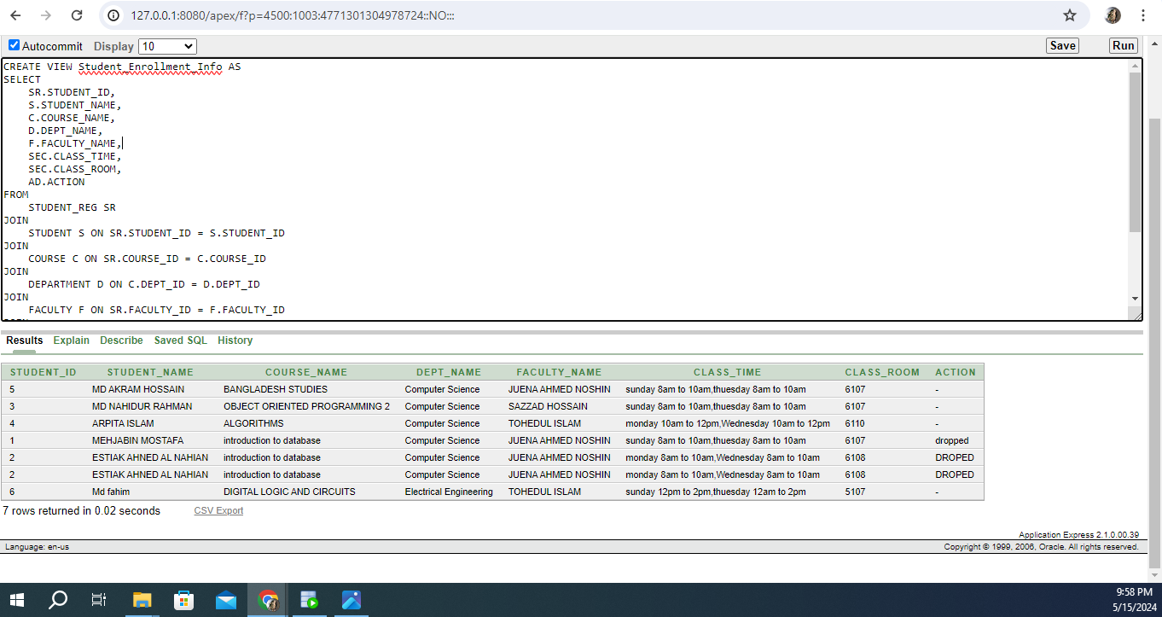

# Relational Algebra:

**1. Projecting Student Names and CGPA:**

**Π**(*STUDENT_NAME, CGPA*(**STUDENT**))

2. Selecting Courses Offered by Computer Science Department:

**𝜎**(*DEPT_ID=1*, **COURSE**)

3. Joining Student Registration with Course and Faculty:

**Π**(*STUDENT_REG.STUDENT_ID, STUDENT_REG.COURSE_ID, COURSE.COURSE_ID, COURSE.DEPT_ID, FACULTY.FACULTY_ID)*

(**STUDENT_REG ⋈ COURSE) ⋈ FACULTY**

4. Union of Computer Science and Electrical Engineering Courses:

**Π**(*COURSE_ID, COURSE_NAME, DEPT_ID)* (**𝜎**(*DEPT_ID=1,* **COURSE**) ∪ **𝜎**(*DEPT_ID=3,* **COURSE**))

5. Projecting Student Names and Their Enrolled Course Names:

**Π**(*STUDENT.STUDENT_NAME, COURSE.COURSE_NAME*)

(**STUDENT ⋈ STUDENT_REG) ⋈ COURSE**

# Conclusion:

The Course Registration Management System is developed to streamline course enrollment, enhance teaching and learning, and provide efficient administrative management of academic programs and student records.

Key functionalities include student enrollment, course details management, instructor assignments, user-friendly interfaces for students and instructors, administrative tools for course management and reporting, and implementation of security measures to protect sensitive data.

Ultimately, the system aims to optimize the course enrollment process, foster academic success, and empower administrators with the necessary tools for effective management of academic programs and student records.